STUDENTS DETAILS
NAME:VINCENT MBUSA
REG NO: BBIT/2024/73420
UNIT CODE:BIT 3208
UNIT NAME:ADVANCED WEB DESIGN AND DEVELOPMENT

PROJECT DETAILS
TITLE:INVENTORY MANAGEMENT SYSTEM
TECHNOLOGIES:
Php + MySQL

GITHUB LINK:

Contents
WEEK 1 :Local Environment Setup 3
Title:Installation and testing of local development environment 3
WEEK 2:Wireframes and GUI Design 8
Title : User Interface Planning and System Design 8
WEEK 3 :JavaScript and PHP Basics 11
Title : Frontend Interaction and Backend Foundations 11
WEEK 4:Understanding Server-Side Programming 15
WEEK 5:Database Components and CRUD Operations 17
Title : Building data-driven systems using databases 17

WEEK 1 :Local Environment Setup

Title:Installation and testing of local development environment

Figure 1:Installation of xampp which was successful
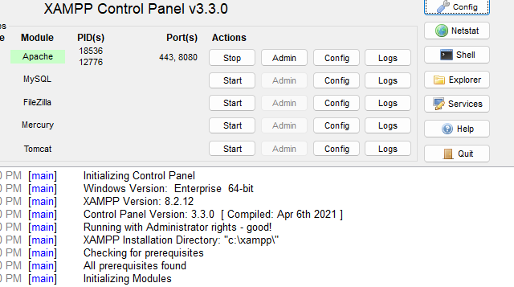

Figure 2:Apache and MySQL Running
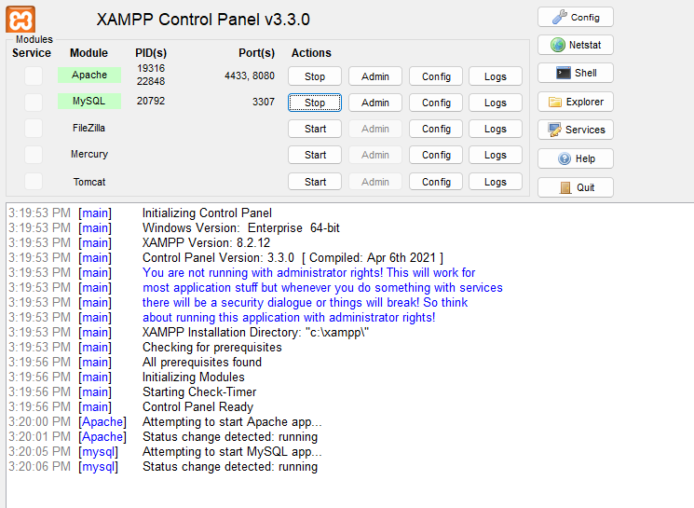

Figure 3:Localhost Test Page
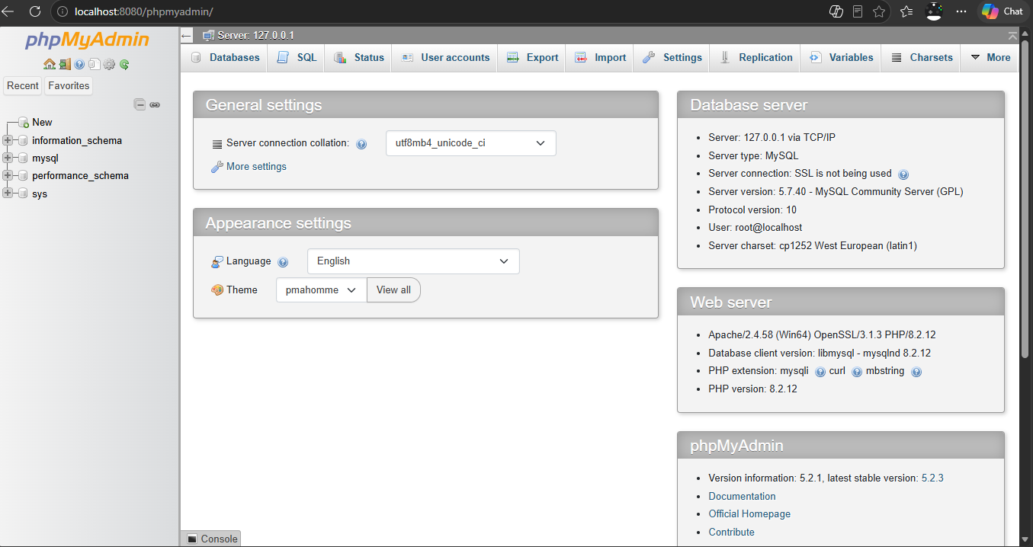
This confirms that xampp is installed and showing browser running localhost .

Figure 4:Hello World Test
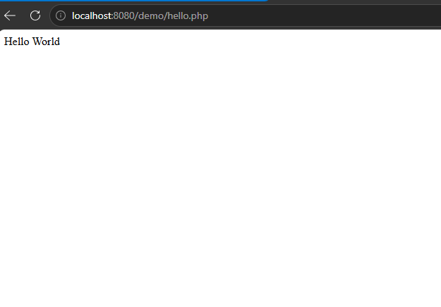
This confirms my first HTML page running and showing its working .
Figure 5:Database Connection Test
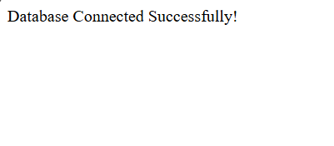
This confirms successful DB connection .

MY REFLECTION ;

WHAT I LEARNT
-am able to create and manage databases using MySQL
-also build web pages using HTML and CSS
-apply CRUD operations which is create,read,update and delete very well without any complications .

CHALLENGES
- Database connection errors caused by incorrect MySQL details.
- PHP syntax errors that prevented pages from loading correctly.

WHAT THE SCREENSHOTS DEMONSTRATES

- The Login Page showing user authentication functionality.
-The Products Page showing stored inventory records.
-The Add Product Page demonstrating product registration functionality.
-Database tables in phpMyAdmin showing stored user and product information.

WEEK 2:Wireframes and GUI Design

Title : User Interface Planning and System Design

Figure 6:Hand drawn wireframe
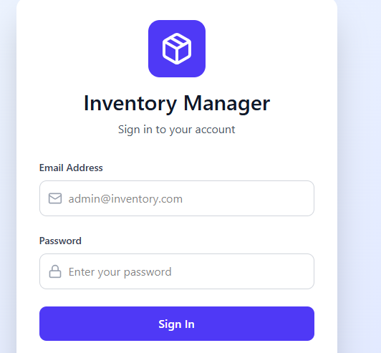

Figure 7:Dashboard Layout Design
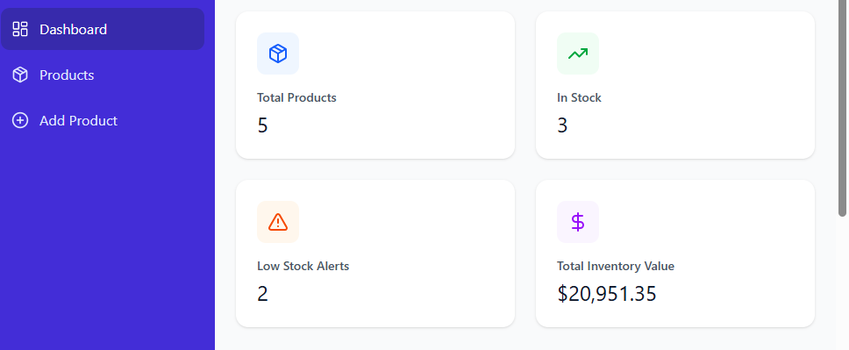

Figure 8:Mobile view mockup
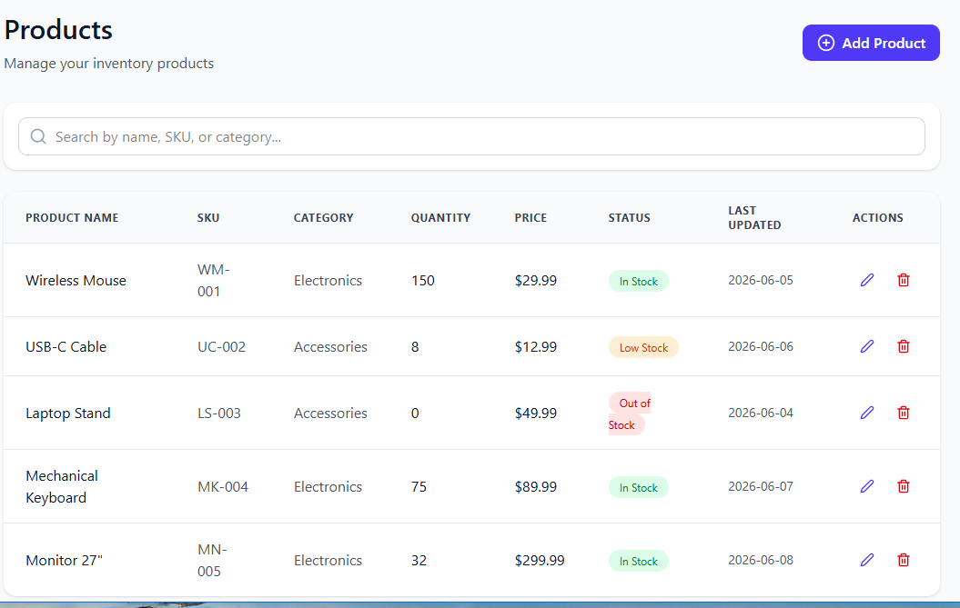

Figure 9:GUI prototype
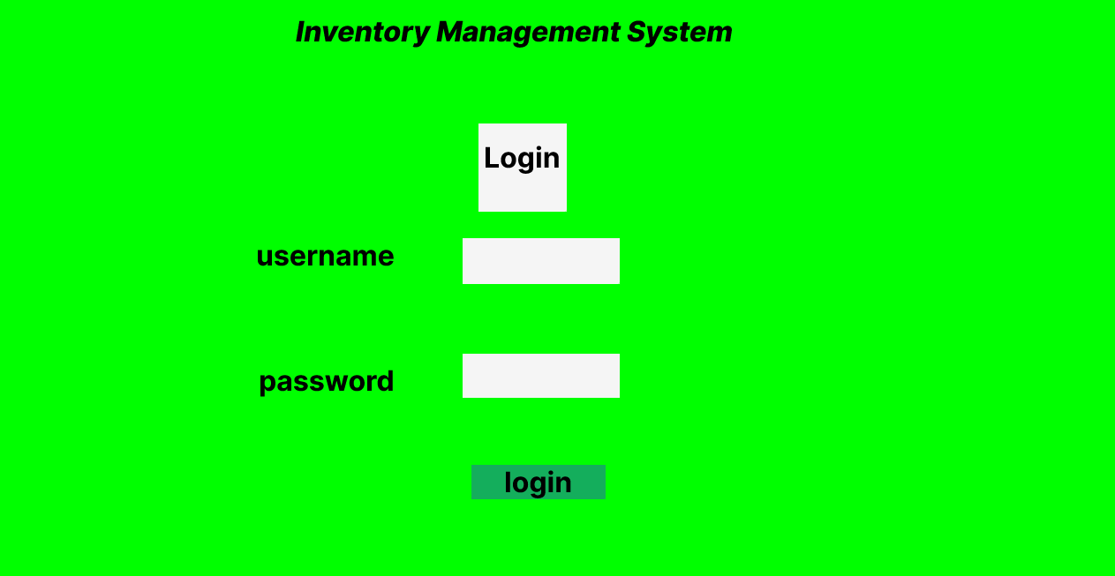

STUDENT REFLECTION
-I selected Figma because its simple,organized and suitable for inventory management system.
-its readable as it has clear fonts ,proper spacing and well organized .
-navigation flow:login page
Dashboard
Products
Add/edit/delete products
Log out

WEEK 3 :JavaScript and PHP Basics

Title : Frontend Interaction and Backend Foundations

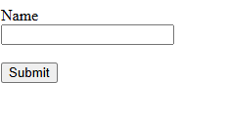

Figure 10:javascript form validation


This two pictures confirms form validation after submitting the correct name there as “Vincent”.

Figure 11:password strength checker
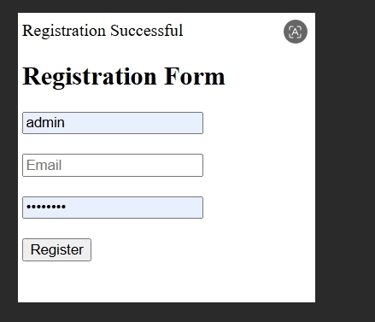

Registration was successful since I keyed in the correct password and it accepted it and produced the output of complete success.

Figure 12:PHP Syntax Practice
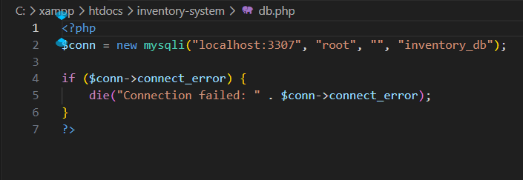

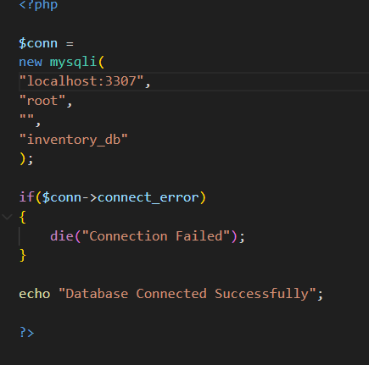

Figure 13:Database Connection Script
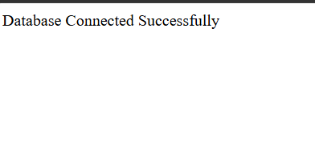

Figure 14:practiced DOM manipulation
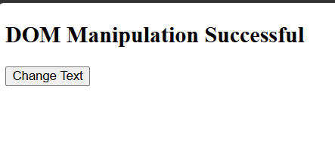

Figure 15:practiced basic database connection
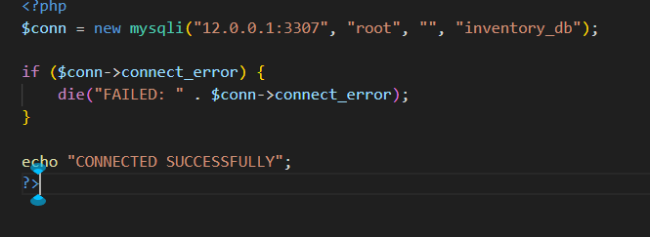

WEEK 4:Understanding Server-Side Programming

Figure 16:Dynamic welcome page


Figure 17:contact form
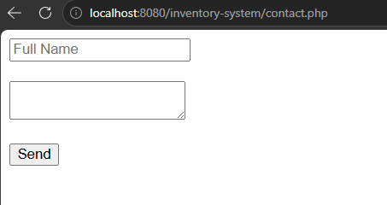

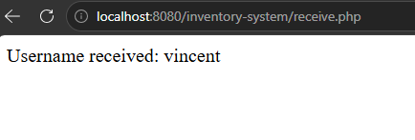

Figure 18:session based welcome page
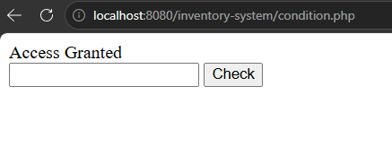

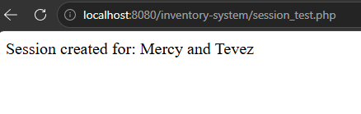

WEEK 5:Database Components and CRUD Operations

Title : Building data-driven systems using databases

